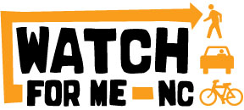

Watch for Me NC

Communications Toolkit
2021

Contents
Watch for Me NC Communications Toolkit Overview 3
Watch for Me NC Program Overview 3
Communications Contacts 4
Program Timeline 5
Watch for Me NC Communications Options 5
Program Materials 5
Tracking Watch for Me NC Material Distribution 5
Posters 5
Rack Cards 8
Warning Ticket Books 9
Bicycle Lights 10
Reflective Bracelets/Arm Bands 10
Banners 10
Distribution Strategies 10
Purchased Media 11
Earned Media 11
Grassroots/Word-of-Mouth 12
Watch for Me NC Messaging 13
General Tips and Example Messaging 13
Tips for Discussing Crash Events 16
Suggestions for Collaboration 18
Suggestions for Editorial Calendar 20
Appendix A. Template Press Releases 23
Program Launch 23
Enforcement Launch 24
Reoccurring Pedestrian Enforcement Operation 25
Bicycle Enforcement Launch 26
Seasonal Press Releases (Back to School, Halloween, and Holidays) 27
Appendix B. Watch for Me NC Program Talking Points 30
Appendix C. Watch for Me NC Safety Tips for Road Users 33
Safety Tips for Drivers 33
Pedestrian Safety Tips 33
Bicyclist Safety Tips 34

Watch for Me NC Communications Toolkit Overview
The Watch for Me NC (WFM) Communications Toolkit is intended to help better explain the outreach tools and resources available to WFM partner communities and to provide assistance for local coordinated efforts. The toolkit provides the basics in explaining the WFM program, communications materials, and communications strategies. It also offers best practices, tips, sample messaging, and talking points for sharing WFM messages across multiple platforms.
It should be noted that communications strategies for WFM efforts are intended to enhance other WFM work within communities. Communications alone will not lead to improved pedestrian and bicyclist safety. While communications activities are a critical piece to help create awareness or share important community information, it will not lead to major behavior change or a culture of safety without education, engineering, and enforcement activities. The WFM program is not a marketing campaign.
Ultimately each WFM community is responsible for developing and executing their own communications plan. The purpose of a communications plan is to increase awareness of:
- local community work;
- safety issues related to pedestrians and bicyclists; and
- how all road users can help keep each other safe.
Watch for Me NC partner communities may have several key coalition members coordinating and contributing to the plan. It is advised that all coalition members of the partner community review the toolkit in its entirety to gain a better understanding of the opportunities for communications efforts and then assign roles and responsibilities to coalition members to build a comprehensive communications plan.

Watch for Me NC Program Overview
Pedestrian and bicyclist safety is an important issue for the health, safety, and mobility of all North Carolinians. People in communities across the state want the ability to walk and roll within their towns and cities and travel safely between their homes, schools, work, businesses, and other critical services regardless of how they choose to travel. Walking, biking, or using another form of transportation to get around may also be a recreational activity for people of all ages. Some people walk or bike as a choice and others due to necessity as an affordable form of transportation. There are many reasons for why people walk or bike.
However, transportation design has historically focused on accommodating motor vehicle-based travel and has not prioritized safe infrastructure for walking and biking. This has led to barriers and challenges that prevent people from walking and biking safely. This can be seen quite literally, for instance, in areas with few or no sidewalks, or disconnected sidewalks. Other challenges may be harder to visually see, such as in the case of when poor design and planning actually encourages unsafe behaviors. Speeding, for example, is an unsafe behavior that is enabled when road design supports high motor vehicle speed and strategies to decrease speed are not employed.
Challenges in road safety can result in severe or fatal consequences. On a national level, the number of overall traffic fatalities decreased over the last decade. The proportion of people killed outside of the motor vehicle, however, including pedestrians and bicyclists, has risen during the same time period. This trend is reflected in pedestrian and bicyclist fatalities in North Carolina. More than 3,200 pedestrians and 900 bicyclists were hit by motor vehicles in 2019 in North Carolina, with a large majority of these people sustaining injuries.
The WFM program, a statewide road safety program launched in 2012, specifically aims to reduce pedestrian and bicyclist injuries and deaths through a comprehensive, targeted approach of public education, community engagement, and leveraging specific law enforcement efforts. This Communications Toolkit weaves these three approaches together to help communities raise awareness of pedestrian and bicyclist safety issues and laws for all members of a community to create a culture of safety. Since WFM efforts are community-led by the partner WFM communities and coalitions they build, this Communications Toolkit aims to help with local communications strategies.

Communications Contacts
There are three different levels of communications contacts within the WFM program:
- Highway Safety Research Center (HSRC) WFM Team
The WFM technical delivery team is here to help your local community with WFM education and training efforts. Through financial support from a Governor’s Highway Safety Program grant, the WFM technical team coordinates the statewide annual program, delivers training for law enforcement officers and other members of the local coalition, and facilitates action planning workshops. The WFM technical team also assists with communications strategies and is responsible for the distribution of printed WFM materials and other collateral (see Program Materials) for WFM communities to use at local events.
- N.C. Department of Transportation (NCDOT) Communications Office
The NCDOT Communications Office leads a purchased media campaign for increasing awareness of WFM messaging across the state. NCDOT typically spends $150K on media buys and materials that are deployed in media market areas containing WFM partners, which is also made possible due to grant funds from the Governor’s Highway Safety Program. Media buys have included placements like internet radio advertisements, car wrap advertisements, take out delivery bag inserts, cooler handles, and other creative media (see Purchased Media). NCDOT also helps bolster the program by sharing important program announcements via press releases, such as the call for partner communities, and annual partner participants. NCDOT also has regional communications contacts
who will be able to work with local coalitions for messaging and distribution in local media outlets.
- Local Partner Coalition Communications
The local partner coalition communications contact is the person or team who champions communications within their local community. This person or team may be situated within a municipal or MPO communications office or may be a law enforcement officer who is leading an effort for engagement. There’s a good chance that if you’re reading this document for help and advice for WFM communications, then this is you, or at least the hat that you’re wearing for a specific effort! Read on for more help and tips on WFM messaging and outreach.
If you need help coordinating your outreach, have questions about materials, or would like to report any local media coverage or other outcomes, please contact Kristin Blank, Communications Manager, UNC Highways Safety Research Center, blank@hsrc.unc.edu, 919-843-7007.

Program Timeline
Each community will operate on its own annual schedule according to its needs and resources. The WFM Timeline is available on the WFM Partner Resources page and provides a general sense of timing for program activities. Communities generally launch communications efforts when they are officially announced as a partner at the beginning of the year. In the beginning of the program year (typically March through July), partner coalition members attend trainings and workshops. Community coalition members are encouraged to develop or maintain an Action Plan to assist with planning events, public engagement, material distribution, and other key activities. Considerations for communications efforts are built into each activity.

Watch for Me NC Communications Options
As referenced above, communications contacts manage different parts of the WFM materials to help with communications efforts. This includes WFM printed program materials and other collateral and earned media.

Program Materials
HSRC coordinates the development and purchase of WFM program materials and other collateral, such as bicycle lights and reflective bracelets. These materials are distributed to WFM partner communities after a law enforcement officer from the partner community has attended the annual training requirements. All program materials will be shipped to the law enforcement agency contact and address specified on the program application. Although coalition members leading outreach and education efforts may distribute some materials during events, other items are specific to traffic laws related to pedestrian and bicyclist safety and must be distributed by law enforcement officers only. Therefore, it is important that the person distributing these materials has a firm understanding of the laws. Typical types of program materials are listed below along with any restraints on their use.
Tracking Watch for Me NC Material Distribution
Each partner community is responsible for keeping track of their local distribution of WFM materials. This information is required for reporting to the Governors’ Highway Safety Program. Reporting and tracking materials includes specifying quantities distributed and event details. Partner members are encouraged to report their material distribution frequently via an easy-to-use form found on the WFM website. Any partner member may use the form. If you are running low on any materials or have any questions about their distribution, please contact Kristin Blank at blank@hsrc.unc.edu.
Posters
There are four different WFM posters. Two are general awareness posters, and two display tips for pedestrians and bicyclists. Printed posters are delivered as part of the WFM materials. Partners receive 25 English and 25 Spanish language versions of each of the four poster type. Posters in other languages - including Mandarin, French, German, and Italian - are available online and to print or share as images. Posters are also available in two different sizes online. The posters may be distributed by all members of the WFM partner community.

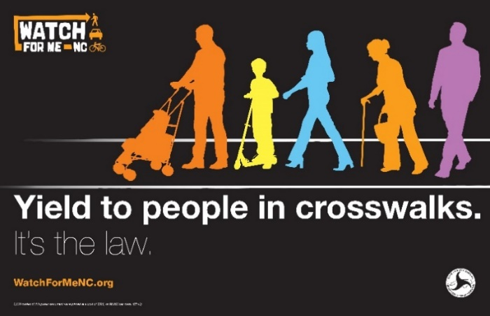
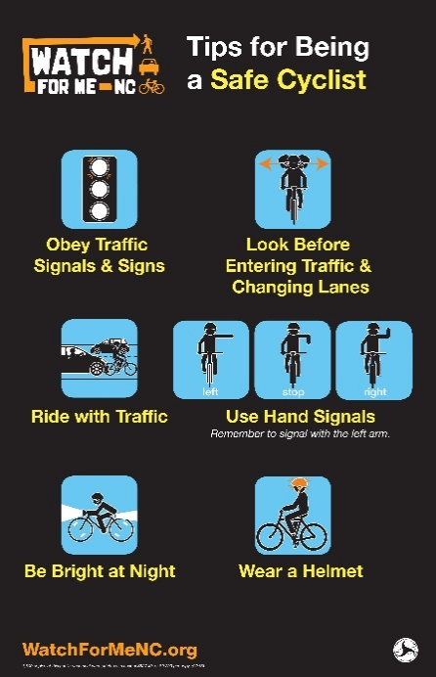
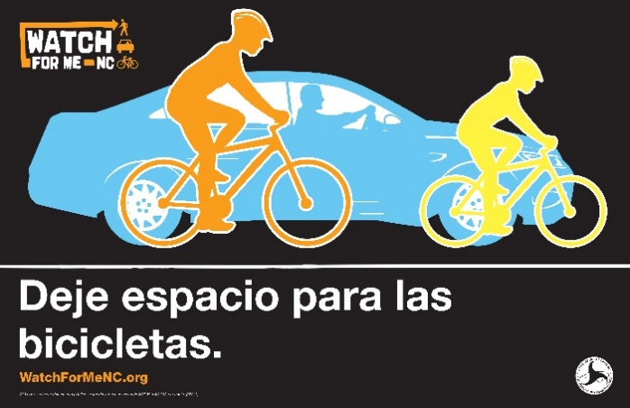
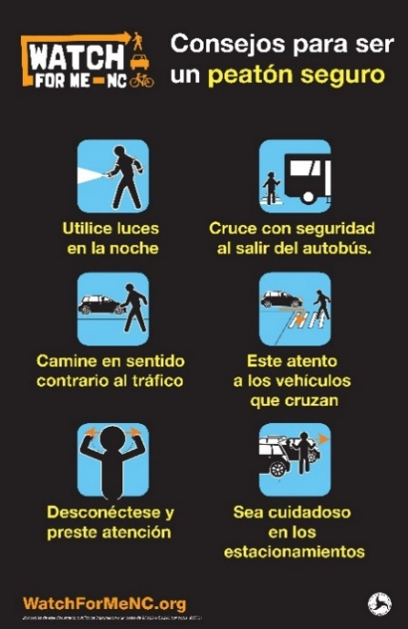
Figure 1. Example WFM posters in English and Spanish language that are printed and distributed to each partner community.
Other posters with safety messages are also available in English and Spanish languages. These posters are available online for partner coalitions to print or distribute via social media. These posters are not included within the printed WFM materials. These posters may be distributed by all members of the WFM partner community.

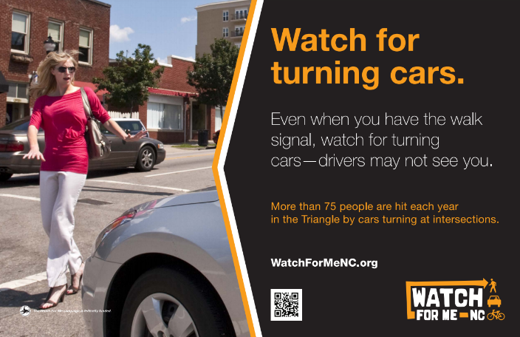
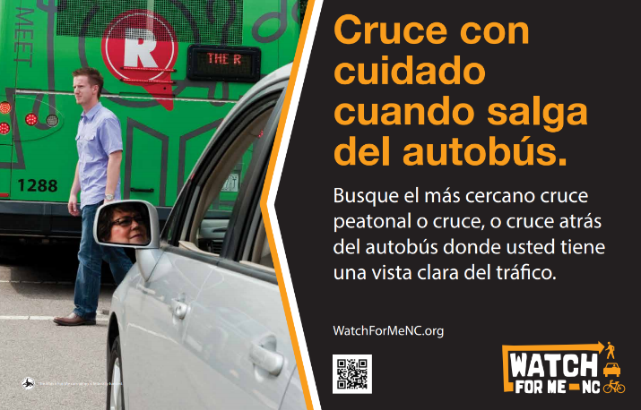
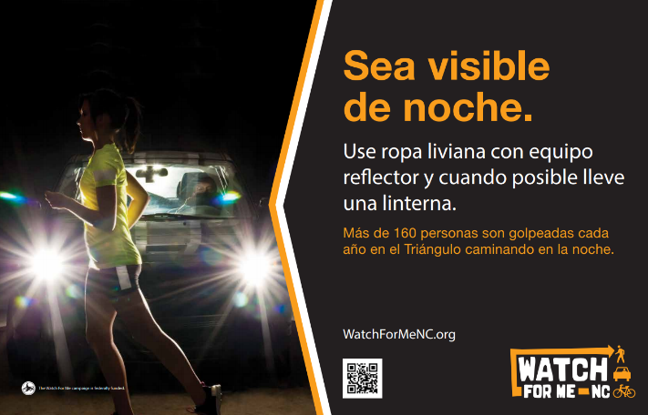
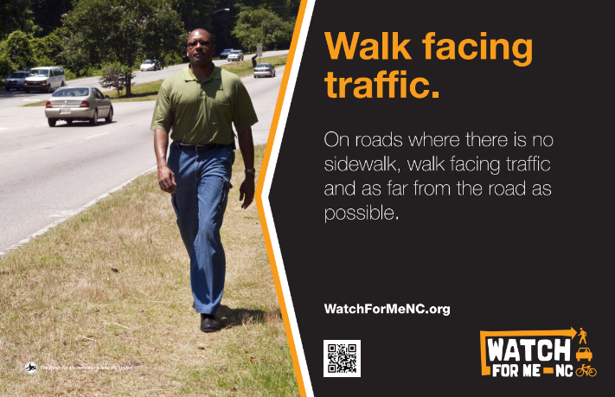

Figure 2. Example WFM posters with safety messages in English and Spanish Language available online.
All posters can also be used for social media messaging, newsletters, and other online applications.
Rack Cards
Rack cards are included as printed materials for WFM communities. There are three types of rack cards that focus on different messaging: one on general traffic safety laws and rules related to drivers, pedestrians, and bicyclists; another has tips for safe behaviors as a pedestrian on one side and a bicyclist on the other; and the third has tips for being a safe driver on the front and back. The general rules and pedestrian and bicyclist safe behavior tip rack cards are available in English, Spanish, Mandarin, French, German, and Italian languages online.
Communities receive 500 of the general rules and tips for being a safe pedestrian and bicyclist rack cards in English and 250 in Spanish. The rack cards may be distributed by all members of the WFM partner community, but it is recommended that non-law enforcement officers distributing the general traffic safety laws have a strong knowledge of the laws. While the general rules rack card is intended to be informative for all, understanding and explaining the rack card may be required at events and while engaging with the public.

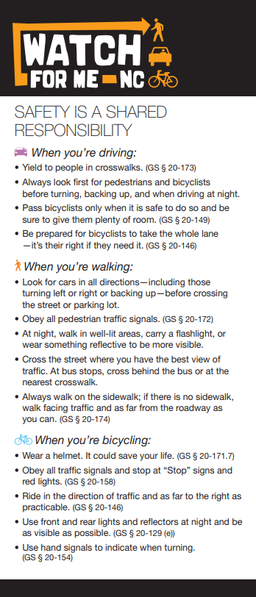
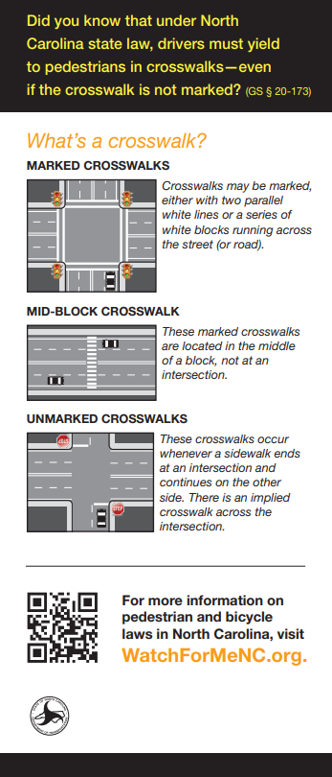
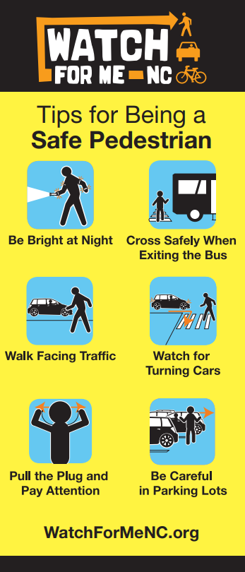
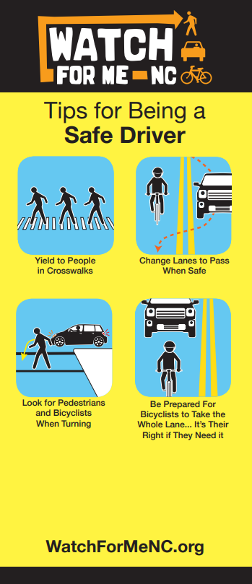

Figure 3. WFM rack cards.

Warning Ticket Books
Communities also receive 15 books with warning tickets printed on tear-off sheets. The warning tickets are intended for distribution by law enforcement officers only and may be used in lieu of citations while providing a way for the officer to inform community members about traffic laws related to pedestrians and bicyclists. Law enforcement officers should have a strong knowledge and understanding of the laws when distributing warnings and communicating laws to the public.

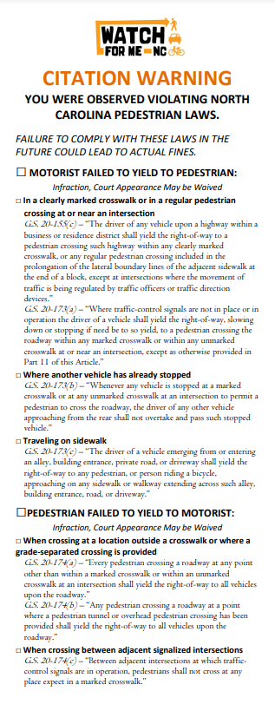
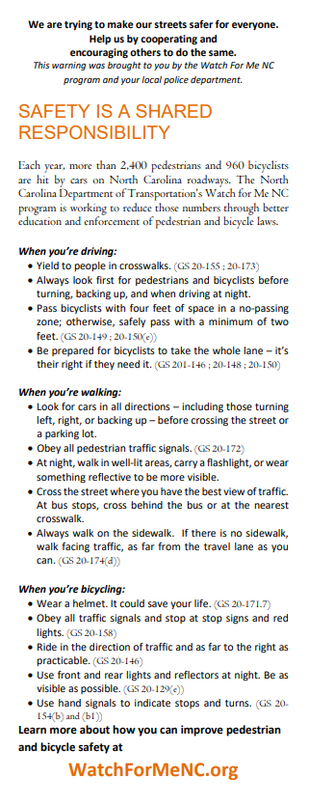

Figure 4. WFM Warning Ticket.

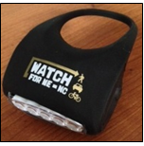
Bicycle Lights
Bicycle light sets (front and rear lights) are also included as part of the WFM collateral. Only law enforcement officers may distribute bicycle lights. It is recommended that law enforcement officers distribute lights to people who are observed riding without lights in lieu of a citation. They may also be distributed at outreach and engagement events with bicyclists that include a safety education component.
Figure 5. WFM Bicycle Light.
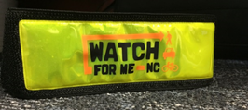
Reflective Bracelets/Arm Bands
Other safety equipment distributed to WFM communities includes reflective bracelets. These also should only be distributed by law enforcement officers to community members. They may be distributed during enforcement operations or at community outreach events with safety education programming.
Figure 6. WFM reflective bracelet / arm band.
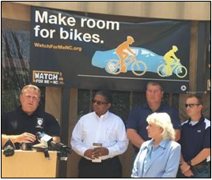
Banners
Communities new to the WFM program receive two vinyl banners with WFM messaging. Banners are not considered distribution materials. WFM partners are encouraged to use the banners at safety outreach and education events, or as the background of media events.
Distribution Strategies
As road safety impacts everyone, WFM materials may be used broadly within a community. As the goal is to increase awareness of not only the program but also introduce safe behaviors, materials should be placed in areas of high visibility or distributed when there is an opportunity for education and engagement.
Figure 7. WFM banner at media event.
Partner members may also coordinate distribution through various organizations and outlets, such as law enforcement agencies, parks and recreation departments, planning departments, or public health departments. Other strategies include reaching organizations to post or distribute materials that are usually not considered as traditional traffic safety partners, such as chambers of commerce, faith-based organizations, or schools. Specific local businesses, like bike shops, or barber shops and hair salons, may also be approached to share messages. Sharing materials widely with key community members helps create a community norm for pedestrian and bicyclist safety.
Other unique approaches to WFM material distribution include:
- Placing materials around community facilities, including:
  - grocery stores
  - libraries
  - older adult centers
  - city/town halls
  - privately-operated NC license offices
  - local businesses
  - farmers’ markets
- Hanging banners near areas that are considered higher risk for non-motorists.
- Incorporating digital materials on City TV channels, websites, social media feeds, or on municipal utility bills.
- Providing materials to schools and/or children around Walk or Bike to School Days (observed in October and May, respectively), bike rodeos, helmet giveaway events, etc.
- Placing materials in other community-coordinated distribution programs, such as lunch bag pick up programs.
- Hanging banners in background for media events on planned road safety updates or infrastructure improvements.
- Distributing at university or college campus orientation events.

Purchased Media
In addition to providing WFM safety and training materials for distribution, the WFM program also provides purchased media for markets across the state. The NCDOT Communications Office leads the purchased WFM media campaign that aims to increase awareness of key safety messages. The media campaign typically launches in late summer and runs through the fall season each year. The campaign typically focuses on targeted audiences of pedestrians, bicyclists, and drivers, and market areas are selected based on location of WFM partners.
In recent years, media buys and advertisements have included: car wraps; clean graffiti; transit posters and wraps; delivery take out bag inserts; and radio PSAs with visual banners on Pandora, a streaming music application.

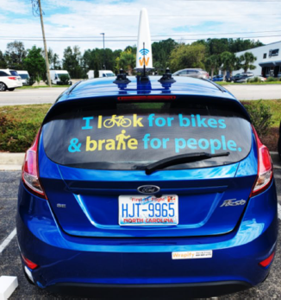
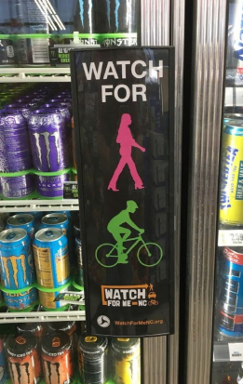
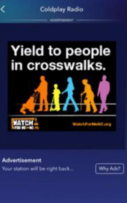
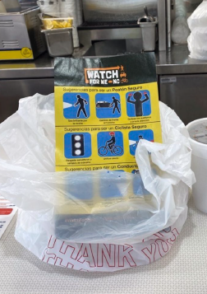

Figure 8. Media placements used in the 2020 WFM program year.

Earned Media
Purchased media messaging and WFM material messaging can be further amplified within local communities by highlighting these efforts through earned media. WFM community partners can raise awareness by earning media attention through traditional media, including newspaper, television, and radio news programs.
Press releases about the WFM program issued by HSRC or NCDOT may also be circulated through local media markets. The NCDOT typically highlights the WFM program twice each year. These press releases cover the call for new community partners and application process, and the program partner announcement. Once formally accepted into the WFM program, many program participants leverage the NCDOT press release to issue a more community-specific announcement within their own community.
Other press releases may be timed to announce other community events or occasions with a focus on pedestrian and bicyclist safety. These include planned enforcement operations events and seasonal safety reminders, such as back to school at the end of summer, or Halloween.
Earned media surrounding enforcement events are particularly important to increase awareness. Law enforcement agencies should work closely with communications and public information staff to highlight enforcement efforts, educate the public about key laws to protect pedestrian and bicyclist safety, and warn road users about the potential consequences of not obeying state and local laws.
Appendix A provides press release templates for WFM communities to use or adapt to pursue local media coverage. Appendix B provides talking points about the program and pedestrian and bicyclist safety for those who may be interviewed by the media. All local media coverage is archived on the WFM Media Coverage and Press Releases webpage. NCDOT also provides regional communications contacts who will be able to work with local coalitions for messaging and distribution in local media outlets.

Grassroots/Word-of-Mouth
Grassroots/word-of-mouth communication can be a powerful and economical way to spread safety messages and is an important complement to advertising and earned media. It depends heavily on participation of local pedestrian and bicycle coordinators, community activists, and other groups. The goal is to raise awareness and generate “buzz” about the program through social media and other local networks. The next Watch for Me NC Messaging section will discuss talking points and communications strategies.
Each community partner should aim to contribute to grassroots-style communication, in coordination with the broader program communications plan. Following are some recommended strategies for getting the word out:
- Post regular updates about the WFM NC program through e-mail blasts, Facebook, Twitter, blogs, etc.
- Share information about the program or make presentations at meetings with local or regional groups. The following list provides an example of groups and is not exhaustive:
  - Youth-oriented groups, including schools, daycares, or camps
  - Town or city agencies, such as Health and Human Services, Parks and Recreation, Planning and Engineering
  - Advocacy groups, such as those oriented towards biking and walking, aging in place, or nature conservation groups
  - Local business organizations, such as bike shops or Chambers of Commerce
  - Educational or training opportunities, such as drivers’ education classes or English as a second language courses
- Send driver, pedestrian, and bicyclist safety messages to local listservs, such as bicyclist and pedestrian advisory committees, housing associations, or neighborhood messaging boards.
University-specific opportunities may also include:
- Announce program to stakeholder groups, such as a pedestrian safety committee or student safety committee
- Send safety messages to those listed on a Bicycle Registration system (universities often have such systems) or the Transportation Demand Management commuter registry
- Leverage student groups (such as sustainability, bicycling co-ops, or environmental or service organizations) to disseminate safety messages to peers

Watch for Me NC Messaging
How pedestrian and bicyclist safety issues are framed in public communications efforts influences community values and norms. Given the wide variety of approaches to increase awareness and provide education through communications channels, WFM provides an opportunity to prioritize non-motorized road user safety. Prioritizing active travel within a community encourages more people to walk and bike, which results in numerous benefits related to health, local economy, the environment, and more. The following section provides tips and guidelines on how to frame these conversations with the community through social media and other media outlets. These tips and guidelines help promote pedestrian and bicyclist safety as a shared community value. They also provide some assistance in discussing sensitive issues, such as when discussing a specific crash scenario.

General Tips and Example Messaging
Capturing the complexity of road user safety through a social media Tweet or Facebook post, or a short press release for media outlets, is challenging. Communications efforts are typically required to be concise and to the point and in plain language for all audiences. Even in these succinct messages, there are specific words and ways to depict certain messages that signal a stronger cultural meaning to the audience. The following tips offer advice in language and visual elements to help build community values in recognizing non-motorist safety:
- To a certain extent, road safety between a driver and non-motorist is a shared responsibility. It is true that people walking and cycling can practice safe behaviors, such as wearing reflectors and lights at nighttime, or walking on sidewalks where they are provided. Practicing safe behaviors, however, is not enough to keep a pedestrian or bicyclist safe in all situations. A person driving a motor vehicle assumes a greater responsibility simply by operating a vehicle that is of greater weight and that is traveling at a higher speed. Drivers inside of a motor vehicle are also afforded a level of protection that is not extended to those on foot or bicycle. To address these specific concerns:
  - Place greater emphasis on driving behaviors over pedestrian and bicyclist behaviors by always listing safe driving tips before tips for non-motorists.
  - Introduce the inherent vulnerability of people walking or cycling by emphasizing their higher risk for injuries and deaths in a crash scenario.
Example messaging: “Driving behavior can impact people who walk and bike and, in a crash, pedestrians and bicyclists are at a higher risk for serious injuries and deaths.”
- Everyone is a pedestrian at some point. Use language that normalizes walking within communities and creates a shared value.
Example messaging: “Everyone is a pedestrian.”

- Some communities may even seek to encourage more walking and biking in their communities. Many places are striving to increase access via walking or biking to encourage local economies and decrease traffic congestion. Reminding community members that shorter trips can be done by non-motorized modes can help influence uptake and encourage the norm for walking and biking in communities.
Example messaging: “Not only is walking or biking a healthy option for getting to the local ____(insert area attraction- farmers’ market, library, grocery store, etc.), it’s so easy thanks to our sidewalks, bike lanes, and marked crosswalks.”

- Emphasize that everyone has the right to the road. There are many places where roads do not have the infrastructure to support the separation of pedestrians and bicyclists from drivers. This does not mean that people walking or biking should not use that road. It is also not illegal for them to use the road. Use language that enforces the belief that everyone has the right to the road in different modes.
Example messaging: “Be prepared for people bicycling to take the whole lane… it’s their right if they need it.”

- Link messaging to events that are related to road traffic safety where pedestrian and bicyclist safety is highlighted. These may be events that are held within the community, or may be larger, broader efforts to advance safety by other organizations. These may be messages that relate to national campaigns around pedestrian safety, such as National Pedestrian Safety Month (annually in October), Bike Month (annually in May), or health awareness campaigns led by local health departments.
This type of messaging signals that road safety is a complex topic that reaches other areas is being prioritized by multiple stakeholders and organizations within and beyond the community. See the Suggestions for Editorial Calendar section for more ideas and tips for expanding community-related values to larger, broader initiatives.
Example messaging: “October is Pedestrian Safety Month. We’re sharing tips for being a safe driver each week to help keep pedestrians safe. More than 100 people are hit by vehicles each year in parking lots around the Triangle region. Pay attention and watch carefully for people walking behind or through parked vehicles.”
- Link messaging to seasonal occurrences that are typically thought of as times when non-motorist travel may be heavier or there may be new temporal patterns. For instance, Halloween, back to school schedules, or daylight savings time changes are examples of travel mode shifts or travel patterns in different conditions.
Example messaging: “October 6 is Walk to School Day. Year round #WatchForMeNC efforts help keep kids safe on their trip to school! #WalkToSchoolDay”
“Daylight saving time ends Nov. 7 and that means it’s getting darker earlier. Be aware of people walking and biking at night and help them get home safely!”
- When covering crash scenarios, never use the word “accident.” Instead, use the word “crash” or “collision.” The words “crash” or “collision” place more emphasis on the actual occurrence, rather than the word “accident” which is more abstract and less specific than the actual event. The word “accident” also implies that crashes are unavoidable problems. Discussing crash events is a sensitive topic and the next section focuses on crash events solely to help provide more context and tips. AAA recently announced that they will be using the word “crash” starting in 2021 and lays out many additional reasons why.
- Use messaging to inform people about laws. For instance, in 2016, a change to NC General Statute §20-150(e) was passed to allow a driver to cross a marked no passing zone, or completely enter the left lane, when passing a bicyclist going straight and in the same direction, so as to give a minimum of four feet passing distance. Sometimes a visual element should be paired to better explain the law.
Example messaging: “Change lanes to pass a bicyclist safely. Give 4’ passing distance.” 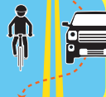
Figure 9. Visual from Tips for Being a Safe Driver Rack Card.

- Focus on potential solutions or positive behaviors instead of issues alone. Consider the wider context of the issue, such as lack of infrastructure or facilities for pedestrians and bicyclists and what the community may do to address these issues. For instance, an intersection with low rates of driver yielding to pedestrians and bicyclists may be addressed by a law enforcement operation intervention to bring awareness and education to that specific intersection and others within close proximity. Giving advance notice of this operation to the public helps introduce this concept.
Example messaging: “People in crosswalks have the #rightofway.” Law enforcement officers will be conducting enforcement operations on ____ (road or at intersection) in _____ (community) on _____ (date) to help remind drivers to yield to people in the crosswalks. “ (See sample Reoccurring Pedestrian Enforcement Operation press release for more information and context.)

- Pair visual graphics with complex ideas, particularly when it relates to road safety laws. The WFM rack cards provides some visual aids, demonstrating safe driver behaviors related to laws, understanding bicyclist hand signals, and laws related to right-of-way at crosswalks.

- Avoid graphic, gory images or fear tactics. Do not include images of crashes, or road users who have been struck by motor vehicles.

- If you are including images or photos of people bicycling, always feature “casual” road cyclists (wearing normal clothing), not racing bicyclists in Lycra. In doing so, this demonstrates that bicycling is a common mode that can be accessible to those who choose to do so, and not specific to specialized, athletic purposes only. Every bicyclist should also be wearing a helmet to promote safe behaviors, much like an image of a driver would show them wearing a seat belt. Be sure to use images that have been approved for public use and credit images appropriately. The Pedestrian and Bicycle Information Center PedBikeImages hosts a photo library of images for noncommercial informational and educational use.

Tips for Discussing Crash Events
Communications around crash events should be considered carefully as this is not only a sensitive topic, but traditionally, media coverage of these events has been biased against people walking and biking, ignoring the larger context of issues that led to the crashes.
Media stories typically cover the people involved in a crash. However, word choice in this coverage is important. While people walking or biking are referred to as “pedestrians” or “bicyclists,” drivers of vehicles are depersonalized and are commonly referred to as “the vehicle.” Think about how many times you may have a read a newspaper item that refers to a pedestrian or bicyclist being “struck” by a “car” or a “vehicle.” The “car” in this phrase is really the “driver,” but by shifting the role and responsibility of the “driver” to an object, it deemphasizes the role of a driver in the larger context of road safety.
This structure is problematic for another reason. The focus of this phrase is the “pedestrian” or “bicyclist” being struck. The focus emphasizes their role of the event, and even if inadvertently, implies blame in this scenario. The sentence structure also uses passive voice instead of active voice, which distances the action of the driver of the motor vehicle from the scenario. Language patterns have the ability to persuade public perception, and when used consistently, can create bias or assign blame to non-motorists for crashes, when in reality, they are the victim in a crash.
Another issue that frequently occurs in media reporting is word choice in describing the crash event and referring to them as “accidents” instead of crashes. As mentioned in the section earlier, under General Tips, the word “accident” is not specific and also implies that the event was inevitable. Repeated references to inevitable events may lead to frustration or apathy, when, in context, most crashes are preventable. Using more specific language and referring to it as a “crash” better defines the issue.
Finally, one of the other issues that appears frequently in media coverage of crashes is the lack of contextual information:
- First, media traditionally lacks temporal context, and treats a crash event as an isolated incident, instead of as part of a persistent, ongoing issue.
- Second, media often omit details about the context of the road or infrastructure where the crash happened. For instance, speed limit or lighting at night are often not included in reporting, which would provide more information to the public about the conditions of the road. By providing this information, media consumers would be able to understand the context of the crash, and either consider their own behaviors in a similar situation, or appeal to the city or town to make safety improvements in infrastructure.
- Third, media will sometimes focus on details about the victim of a crash instead of a more holistic perspective, such as the lack of a bicyclist wearing a helmet, or a pedestrian wearing dark clothing or not having a flashlight after dark. This draws more attention to the victim’s role in the crash, infers that the victim is at fault, and results in victim-blaming.
When reporting on crashes, there is an opportunity to place the crash event within a larger, persistent issue of pedestrian and bicyclist safety. Reporters and communicators may want to look at crash data to inform patterns and trends in crashes. The North Carolina Pedestrian and Bicycle Crash Data Tool (NCPBCAT) is an online database that provides information on crashes between drivers of motor vehicles and bicyclists or pedestrians. The data offered through the tool is reported to NC Division of Motor Vehicles by investigating police officers.
There are a few caveats and best practices to mention before relying on NC PBCAT to inform a story. First, it is recommended that communicators review the NC Pedestrian and Bicycle Crash Facts Summary Reports (2015-2019) to learn more about patterns and trends in crashes. Other basic information about using crash data as background information in a story includes:
- In general, pedestrians are much more likely to die in collisions occurring at night.
- Speeding tends not to be reliably captured in pedestrian crash reporting.
- Crash numbers often do not include specifics that may play a role in crash outcomes, e.g., vehicle types (size, design), infrastructure and built environment issues (existing sidewalk, lighting, land use type), and behavioral health factors (drugs, alcohol).
- Trying to determine a trend based on one year of pedestrian and bicyclist crash data (or the comparison between two) is not useful.
- Police-reported crash data often underrepresents actual numbers of crashes due to unreported crashes, and those that do not involve a motor vehicle. Additionally, crash numbers that are very low or non-existent in some locations may be due to the fact that people are simply not walking or biking there because it is too dangerous.
Before reporting or posting about crash events in your community, it is advised that communicators review three short documents. These documents informed much of the discussion above and provide more information on the importance of framing crash events in media reporting and sample language.
Editorial Patterns in Bicyclist and Pedestrian Crash Reporting provides an analysis of news reports on crashes between drivers of motor vehicles and pedestrians or bicyclists; illustrates the importance of media framing and language; and provides sample language.
Shaping the narrative around traffic injury offers ideas to re-frame conversations about traffic injury and themes and thought prompts for shaping narratives.
Toolkit: Changing the Narrative About Traffic Crashes offers five strategies to change the public narrative about traffic crashes from victim-blaming to solutions.

Suggestions for Collaboration
As mentioned previously within this toolkit, communications efforts should be informed by partner coalition members and organizations. Local coordination serves as a way to inform other partner coalition members and amplifies messaging, which then creates a greater reach to the public in the community. Ideally, each local coalition member organization should be sharing pedestrian and bicyclist safety content through unique posts developed within that organization or reposting or retweeting partner messages.
Beyond internal collaboration communications efforts, there is an opportunity to leverage communications by state or local entities focusing on traffic safety, non-motorized road users, youth mobility and safety, health, and other related topics. These may be regional, state, or national organizations. The following list serves as an example of organizational handles that may be helpful to follow or tag to learn more about pedestrian and bicyclist safety and related topics that tie to your own organizational communications.
Organization | Twitter Handle | Facebook Handle
NC Vision Zero | @NCVisionZero | @NCVisionZero
NCDOT | @NCDOT | @NCDOT
NC GHSP | @NC_GHSP | @NCGHSP
GHSA | @GHSAHQ | @GHSAhq
USDOT | @USDOT | @USDOT
Federal Highway Administration | @USDOTFHWA | @FederalHighwayAdmin
National Highway Traffic Safety Administration | @NHSTAgov | @NHTSA
UNC Highway Safety Research Center | @hsrcinfo | @hsrcinfo
Pedestrian and Bicycle Information Center | @pedbikeinfo | @pedbikeinfo
NC State Institute for Transportation Research and Education | @ITRE_NCSU | @InstituteForTransportationResearchAndEducation
America Walks | @americawalks | @americawalks
National Complete Streets Coalition | @completestreets | @CompleteStreets
Vision Zero Network | @visionzeronet | @visionzeronetwork
Road to Zero | @RoadToZeroUS | @RoadToZeroUS
AARP Livable Communities | @AARPLivable | @AARPLivableCommunities
Walk & Bike to School | @walkbikeschool | @walkbiketoschoolday
Safe Routes Partnership | @SafeRoutesNow | @saferoutespartnership
Institute for Transportation and Development Policy | @ITDPUS | @ITDP.org
Streetsmart | @Street_Geek
8 80 Cities | @880Cities | @880CitiesOrg
PeopleForBikes | @peopleforbikes | @PeopleForBikes
League of American Bicyclists | @BikeLeague | @leagueamericanbicyclists
U.S. Access Board | @AccessBoard
National Aging and Disability Transportation Center (NADTC) | @NADTC.org | @NADTCmobility
National Council on Disability | @NatCounDis | @NCDgov
Healthy Places by Design | @HPlacesbyDesign
American Public Health Association | @PublicHealth | @AmericanPublicHealthAssociation
SaludAmerica | @SaludToday | @SaludToday
Design Justice Network | @design_justice | @designjusticenetwork

Learning from or sharing more with peer WFM partners across the state, is a great way to amplify each other’s messages, so consider connecting with their social media accounts. It may be especially fruitful to connect and coordinate with nearby jurisdictions who are targeting the same population of road users traveling between both communities. Lead agencies for WFM efforts for each partner community are listed in the Contact List from the WFM Partner Resources page. You may also search for #WatchForMeNC on Facebook or Twitter to see peer community announcements.
For collaborating around specific topics, events, or themes around a conversation, use hashtags. Best practices for communications efforts recommends no more than two hashtags per post. This demonstrates that the partner community is addressing issues within the community but that also have connection to larger, national issues or concerns. They also provide more context without using as many words. Popular hashtags to employ include: #WatchForMeNC, #SafeStreet, #SlowDown, #20IsPlenty, and #VisionZero.

Suggestions for Editorial Calendar
Not only can you amplify messaging by leveraging announcements and posts from other organizations, you can also use events or occasions as ways to engage with the public. Building an editorial calendar and thinking about when you may post conversations around WFM topics helps plan for consistent messaging within the community.
First, you may consider your own community calendar. For instance, there may be a local fair or event that occurs each year and encourages heavier traffic on specific days or weekends and there may be more people on foot. Or the audience in your community may be transient, such as in coastal or mountain communities which have heavy tourist seasons. Even thinking about school starting in late summer may be a local annual event to build into an editorial calendar.
Beyond your local annual schedule, there may be regional, state, and national awareness weeks that can be tied to messaging. As pedestrian and bicyclist safety is often related to other diverse topics, such as health, or accessibility, think about how some of the awareness events can be pivoted towards thinking about people walking or biking within your community. For instance, Older Driver Safety Awareness Week in December may serve as an opportunity to share tips about safe driving around people on foot or bike. The following list of events or occasions may all be referenced in creating awareness about WFM and local community efforts. Some dates are referenced as specific to 2021 while others are referenced as annual occurrences.
Date | Event | Type/Leading Organization/Hashtag
January 1 | New Year’s Day | National Holiday
January | Family Fit Lifestyle Month | #FamilyFitLifestyle #FamilyFitLifestyleMonth
January 9, 2021 | National Law Enforcement Appreciation Day | International Association of Chief of Police; #LawEnforcementAppreciationDay
January 17, 2021 | Healthy Weight, Healthy Look Week | Center for Disease Control and Prevention;  #HealthyWeightWeek
February | American Heart Month / National Heart Healthy Month
February 1, 2021 | WFM Applications Due | @GHSP_NC, @NCDOT, #WatchForMeNC
February 7, 2021 | Super Bowl LV | National Sports Event
February 14 | St. Valentine’s Day | National Holiday
March | WFM Partner Announcement | @GHSP_NC, @NCDOT, #WatchForMeNC
March 14, 2021 | Daylight Saving Time Begins | National Event
March 17 | St. Patrick’s Day | National Holiday
April | National Distracted Driving Awareness Month | @NHTSAgov; Campaign Materials
April 1, 2021 | National Walking Day | #NationalWalkingDay
April 11, 2021 | National Pet Day | #NationalPetDay
April 22 | Earth Day | Annual Event
April 26-30, 2021 | National Work Zone Awareness Week | @NC_GHSP; @NCDOT; @USDOTFHWA #NWZAW, #GoOrangeDay
May | National Youth Traffic Safety Month | @NHTSAgov
May | Bike Month | @PeopleForBikes; @leagueamericanbicyclists
May | Family Wellness Month | @leagueamericanbicyclists; #BikeToWorkDay
May 5, 2021 | National Bike to School Day | @walkbikeschool; #BikeToSchoolDay
May 17-23, 2021 | Global Road Safety Week | @UNGlobal, #RoadSafetyWeek
May 21, 2021 | National Bike to Work Day
May 21, 2021 | National Employee Health and Fitness Day
May 26, 2021 | National Senior Health and Fitness Day
May 31 | Memorial Day | National Holiday
July 4 | Independence Day | National Holiday
July 26, 2021 | Americans with Disabilities Day | Anniversary of Americans with Disabilities Act; #AmericanswithDisabilitiesDay
August 16-19, 2021 | NCDOT Traffic Safety Conference and Expo | Annual Event; @NCDOT; #NCTrafficSafetyConference
August 26, 2021 | Women’s Equality Day | #WomensEqualityDay
August 26, 2021 | National Dog Day | #NationalDogDay
Late August/Early September | Back to School | Annual Event
September | Health Aging Month
September | America on the Move / Month of Action | America on the Move Foundation
September 6, 2021 | Labor Day | National Holiday
September 26, 2021 | Family Health and Fitness Day | Health Information Resource Center
October | Pedestrian Safety Month | @USDOTFHWA, @NHTSAgov
October 1, 2021 | International Day of Older Persons | @WHO
First Week of October | Active Aging Week | @AAW_ICAA
October 6, 2021 | National Walk to School Day | @walkbikeschool; #WalkToSchoolDay
October 14-24, 2021 | North Carolina State Fair and Safety City | @NC_GHSP, @NCDOT, #NCStateFair, @SafetyCity
October 15, 2021 | White Cane Safety/Awareness Day | National Federation of the Blind @NFB_voice
October 17-23, 2021 | NHTSA National Teen Driver Safety Week | @NC_GHSP; @NHSTAgov #TeenDriverSafetyWeek
October 17-23, 2021 | National School Bus Safety Week | @NAPTHQ; #NSBSW
October 31 | Halloween | National Event
November 7, 2021 | Daylight Saving Time Ends | National Event
November 21, 2021 | World Day of Remembrance for Road Traffic Victims | @WHO, @UN, @NCVisionZero, @VisionZeroNetwork, #WorldDayofRemembrance
November 24, 2021 | Thanksgiving | National Event
First week of December | National Older Driver Safety Awareness Week | American Occupational Therapy Association @AOTAInc, #OlderDriverSafetyAwarenessWeek
December 24 and 25, 2021 | Christmas Eve and Christmas | National Holiday

Appendix A. Template Press Releases

Program Launch
Watch for Me NC Announces [202_] Partners
[LOCATION], [DATE] – [NUMBER] new communities will soon benefit from participation in Watch for Me NC, a comprehensive, nationally recognized program that focuses on reducing bicyclist and pedestrian injuries and fatalities through public education and community engagement partnerships with local law enforcement.
[QUOTE FROM COMMUNITY LEAD]
The program leverages the strengths of law enforcement and public education to encourage safe and secure places to walk and bike. The Watch for Me NC program selected the following new partners to join [NUMBER] returning communities across the state:
- [COMMUNITY (COUNTY)]

The new partners join [NUMBER] returning communities, which include:

- [COMMUNITY (COUNTY)]
Watch for Me NC community partners will receive free law enforcement training, technical assistance, and safety tools provided by NCDOT and the UNC Highway Safety Research Center. All community partners will be eligible to attend virtual training sessions. Partners will also receive materials with pedestrian and bicyclist safety messages to aid in engagement at public events. In addition, communities will receive support that is individually customized, helping them plan outreach, share opportunities and troubleshoot challenges.
The [YEAR] Watch for Me NC program is supported by the North Carolina Governor’s Highway Safety Program. The UNC Highway Safety Research Center provides technical support with program implementation and evaluation. For more information about the program, visit the Watch for Me NC website.

Enforcement Launch
[INSERT AGENCY HERE] Promote Pedestrian Safety: law enforcement to begin major enforcement of pedestrian laws as part of Watch for Me NC program
[LOCATION], [DATE] – [INSERT AGENCY HERE]-area law enforcement agencies will be stepping up efforts to enforce traffic safety laws as part of the North Carolina Governor’s Highway Safety Program’s Watch for Me NC program.
The pedestrian and bicyclist-focused program began in [MONTH] with a series of announcements promoting safer driver, pedestrian, and bicyclist behaviors. The program now begins its second phase with strategic enforcement of laws, such as assuring that drivers yield to pedestrians in crosswalks.
The program is intended to reduce crashes between drivers and pedestrians or bicyclists through greater awareness and enforcement of key safety laws. Each year in the region, more than [INSERT LOCAL CRASH FIGURE] bicyclists and about [INSERT LOCAL CRASH FIGURE] pedestrians are injured or killed.
[QUOTE FROM COMMUNITY LEAD]
Through the month of [INSERT MONTH], [INSERT AGENCY HERE]-area law enforcement agencies will be conducting enforcement programs at areas where motor vehicle-pedestrian or bicyclist crashes are most prevalent.
The [YEAR] Watch for Me NC program is supported by the North Carolina Governor’s Highway Safety Program. The UNC Highway Safety Research Center​ provides technical support with program implementation and evaluation. For more information about the program, visit the Watch for Me NC website.

Reoccurring Pedestrian Enforcement Operation
[INSERT AGENCY HERE] Promote Pedestrian Safety: [Law enforcement agency] holding pedestrian safety enforcement action at [location]
[LOCATION], [DATE] – [Law enforcement agency] will be conducting operations and educating drivers to keep pedestrians safe at [location].
This operation is part of the North Carolina Governor’s Highway Safety Program’s Watch for Me NC program, which is working to reduce the number of motor vehicle-pedestrian crashes in the state through education and enforcement of pedestrian safety laws. More than [INSERT LOCAL CRASH FIGURE] crashes involving motor vehicles and pedestrians are reported to police in [CITY/REGION] each year.
As part of the Watch for Me NC effort, [Law enforcement agency] officers will be conducting operations at [location] and will be issuing warnings and citations to road users who fail to follow those laws, such as drivers not yielding to pedestrians in crosswalks.
What: Pedestrian safety enforcement operation
When: [Time and Date]
Where: [Location]
The [YEAR] Watch for Me NC program is supported by the North Carolina Governor’s Highway Safety Program. The UNC Highway Safety Research Center​ provides technical support with program implementation and evaluation. For more information about the program, visit the Watch for Me NC website.

Bicycle Enforcement Launch
[INSERT AGENCY HERE] Promote Bicyclist Safety: law enforcement to begin major enforcement of bicyclist laws as part of Watch for Me NC program
[LOCATION], [DATE] – [INSERT AGENCY HERE]-area law enforcement agencies are stepping up efforts to enforce bicyclist safety laws as part of the North Carolina Governor’s Highway Safety Program’s Watch for Me NC program.
Throughout [INSERT MONTH], [INSERT AGENCY HERE]-area law enforcement agencies will be conducting enforcement programs at areas where motor vehicle-bicyclist crashes are most prevalent. Law enforcement officers will educating road users and issuing warnings and citations to drivers and bicyclists who fail to follow state and local traffic laws.
The bicyclist-focused program began in [MONTH] with a series of announcements promoting safer driver and bicyclist behaviors, and the program now begins its second phase with strategic enforcement of bicyclist laws, such as assuring that drivers safely pass bicyclists.
The program is intended to reduce motor vehicle-bicyclist crashes in North Carolina through greater awareness and enforcement of bicycle safety laws.
[QUOTE FROM COMMUNITY LEAD]
The [YEAR] Watch for Me NC program is supported by the North Carolina Governor’s Highway Safety Program. The UNC Highway Safety Research Center​ provides technical support with program implementation and evaluation. For more information about the program, visit the Watch for Me NC website.

Seasonal Press Releases (Back to School, Halloween, and Holidays)
Start of School Year Brings Increase in Pedestrian and Bicycle Activity: Drivers urged to use caution, keep roads safe for everyone
[LOCATION], [DATE] – The start of school on [DAY] means an increase in pedestrian and bicyclist activity on and around school campuses in North Carolina. The North Carolina Governor’s Highway Safety Program encourages drivers to watch out for students walking or biking to and from schools and campus.
[QUOTE FROM COMMUNITY LEAD]
Each year in North Carolina, about [INSERT LOCAL CRASH FIGURE] pedestrians and [INSERT LOCAL CRASH FIGURE] bicyclists are struck by cars. Follow some basic rules of safety:
Drivers
- Be prepared to yield to pedestrians in crosswalks.
- Never pass a vehicle that is stopped for pedestrians.
- Before making a turn, be sure the path is clear of any pedestrians or bicyclists.
- Slow down in areas where you are likely to find pedestrians and bicyclists, such as near bus stops, schools and playgrounds. There is a $250 penalty for speeding in a school zone in North Carolina.
- Keep an eye out for pedestrians and bicyclists at night.
- Avoid distractions such as food, passengers and using mobile devices.
- Give bicyclists a wide berth when passing, and only pass when it is safe to do so.
Students
- Cross in the crosswalk.
- Look for cars in all directions—including those turning left or right—before crossing the street; never assume a driver will stop.
- Be careful crossing multiple lanes of traffic. Make sure each lane of traffic is clear before you cross.
- Pay attention to where you’re walking or bicycling and take the focus off your cell phone or other electronic device. A moment of distraction could have disastrous consequences.
- Be predictable to drivers and follow the rules of the road—obey signs and signals.
- Cross the street where you have the best view of traffic. At school bus stops, cross in front of the school bus or at the nearest crosswalk.
- Always walk on the sidewalk; if there is no sidewalk, walk facing traffic and as far from the roadway as you can. Conversely, when you are on your bike it is best to ride in the direction of traffic. Drivers may not be looking for you if you are riding the wrong way.
- Wear a helmet when riding your bike. It could save your life.
- Use a light and reflectors when bicycling at night and be as visible as possible.
The [YEAR] Watch for Me NC program is supported by the North Carolina Governor’s Highway Safety Program. The UNC Highway Safety Research Center​ provides technical support with program implementation and evaluation. For more information about the program, visit the Watch for Me NC website.

[LEAD AGENCY] Offers Halloween Road Safety Tips
[LOCATION], [DATE] – With thousands of children expected to be parading the streets on Oct. 31, [LEAD AGENCY] and the Watch for Me NC program are offering safety tips to help make this year’s Halloween safer and more enjoyable.
More than [INSERT LOCAL CRASH FIGURE] pedestrians are injured or killed in collisions with drivers of motor vehicles in North Carolina each year, and more than [INSERT LOCAL CRASH FIGURE] of those collisions occur in the evening or at night.
For Drivers
Drivers should be especially alert on Halloween and should:
- Drive slowly through residential streets and areas where pedestrians trick-or-treating could be expected.
- Watch for children darting out from between parked cars.
- Watch for children walking on roadways, medians, and curbs.
- Enter and exit driveways and alleys carefully.
- At twilight and later in the evening, watch for children in dark clothing.
For Parents
Before children start out on their trick-or-treat rounds, parents should:
- Plan and discuss a safe route for trick-or-treaters to follow and establish a return time. Instruct your children to travel only in familiar areas and along the established route.
- Make sure that an adult or an older responsible youth will be supervising the outing for children under age 12.
- Make sure your child carries a flashlight, glow stick or has reflective tape on their costume to make them more visible to drivers.
- Let children know that they should stay together as a group if going out without an adult.
- Review all appropriate trick-or-treat safety precautions, including pedestrian/traffic safety rules.
For Trick-Or-Treaters
To have a safe trick-or-treating adventure, trick-or-treaters should:
- Stay in familiar neighborhoods along the established route and stop only at familiar houses unless accompanied by an adult.
- Walk on sidewalks, not in the street. If there are no sidewalks, walk on the left side of the road, facing traffic.
- Cross streets at crosswalks when available. Look both ways before crossing streets and cross when the lights tell you to cross, after you check for cars in all directions.
- Carry a flashlight, wear clothing with reflective markings or tape, and stay in well-lit areas. Wear a watch you can read in the dark.
- Don't cut across yards or driveways.
The [YEAR] Watch for Me NC program is supported by the North Carolina Governor’s Highway Safety Program. The UNC Highway Safety Research Center​ provides technical support with program implementation and evaluation. For more information about the program, visit the Watch for Me NC website.

[LEAD AGENCY] Offers Holiday Shopping Road Safety Tips
[LOCATION], [DATE] – Did you know that more than and [INSERT LOCAL CRASH FIGURE] people in North Carolina are hit by cars in in parking lots? As more people are starting to frequent shopping centers and malls, [LEAD AGENCY] and the Watch for Me NC program are offering road safety tips to help drivers and pedestrians ensure a safe and joyous holiday season:
For drivers:
- Before backing out, be sure to look in all directions for pedestrians.
- Drive slowly through parking lots as pedestrians and children can dart out from between cars.
- Be sure you have clear sight lines out of your car and that no packages are blocking your view.
- Put away your cell phone and stay focused on driving safely.
- Never assume pedestrians can see you.
For pedestrians:
- Put away your cell phone and take out any headphones to make sure you are not distracted.
- Keep an eye out for cars pulling out of parking spaces. Break lights are a good sign a car is about to back up.
- Be sure to look both ways for cars before stepping into the parking lot.
- Do not run or dart out into the parking lot.
The [YEAR] Watch for Me NC program is supported by the North Carolina Governor’s Highway Safety Program. The UNC Highway Safety Research Center​ provides technical support with program implementation and evaluation. For more information about the program, visit the Watch for Me NC website.

Appendix B. Watch for Me NC Program Talking Points
What is Watch for Me NC?
More than 3,200 pedestrians and 900 bicyclists were hit by motor vehicles in 2019 in North Carolina, with a large majority of these people sustaining injuries. These figures represent only police-reported crashes that make it through the DMV system. Past studies have estimated that police-reported crashes represent only about 56 percent of pedestrian and bicyclist incidents that occur.
Watch for Me NC is a comprehensive program aimed at reducing the number of pedestrians and bicyclists hit and injured in crashes with vehicles through a comprehensive, targeted approach of public education, community engagement, and leveraging specific law enforcement efforts. The program is a collaborative effort with state agencies and local communities.
Who is coordinating the Watch for Me NC program?
The program is sponsored by the Governor’s Highway Safety Program (GHSP). The UNC Highway Safety Research Center leads program management and coordination while the N.C. Department of Transportation (NCDOT) leads the WFM purchased media campaign. The NCDOT leads the WFM purchased media campaign. Each partner community leads their own local efforts through a coalition of community stakeholders representing multiple disciplines (e.g., communications, public health, schools, law enforcement, advocacy groups, planning and engineering departments, etc.).
When did Watch for Me NC first launch?
The N.C. Department of Transportation began planning the Watch for Me NC program in the summer of 2011, but the program officially launched in August 2012 to promote pedestrian safety as a pilot project in the Triangle area. In 2013, the program added bicyclist safety to the mission, and in 2014 it expanded statewide. Each year, the program added several new communities as it continues to grow across the state. More than 60 communities from across North Carolina have participated in WFM over the lifetime of the program. It is anticipated that the materials, messaging, and enforcement efforts inspired by the program will become a regular part of the local, regional, and state safety programs.
Who is funding Watch for Me NC?
Funding for Watch for Me NC initially was provided from 2009 to 2012 by a National Highway Traffic Safety Administration (NHTSA) grant to the UNC Highway Safety Research Center to assess pedestrian crash data and to support the development and evaluation of education and enforcement programs. Additional funding from 2012 to 2020 was provided by NCDOT and GHSP to develop an array of program safety messages, public safety announcements, and other materials. The Governor’s Highway Safety Program provides funding for the program in 2021 to both NCDOT and the UNC Highway Safety Research Center.
Where can I get more information about the Watch for Me NC program?
Please visit the Watch for Me NC program website.
Where can I get Watch for Me NC program materials?
You can download program materials and safety resources from the Watch for Me NC program website program website.
What efforts will local law enforcement officers be taking to reduce pedestrian and bicyclist crashes?
Each year, law enforcement officers in partner communities attend training on traffic laws and enforcement practices related to pedestrian and bicyclist safety. In addition to this training, law enforcement officers are required to also attend two other workshops on topics related to non-motorist safety. Officers apply knowledge learned in these trainings in variety of ways, including outreach and targeted enforcement operations related to pedestrian and bicyclist safety. The enforcement activities help raise awareness of laws requiring motorists to yield to pedestrians in crosswalks, to pass cyclists safety and assure bicyclists are using the proper signals and lighting, among other safe behaviors. Law enforcement units are expected to report statistics on the number of violations (warnings or citations) processed during enforcement events.
Where will law enforcement operations be taking place?
Law enforcement operations will be taking place throughout the state as partner communities plan their own enforcement events. Contact Watch for Me NC partners law enforcement agencies for more information.
What else are cities doing to improve pedestrian and bicyclist safety in NC?
Many cities are using variations on the “Three-E’s” model, addressing pedestrian and bicyclist safety through a combination of engineering, enforcement, and education, and sometimes focusing on emergency response, equity, evaluation, and encouragement. Some communities are passing community resolutions in support of education and enforcement. Others are implementing Complete Streets guidelines to ensure that all roads are designed with proper facilities to support safe pedestrian and bicyclist movement. Several communities are moving toward Vision Zero principles and incorporating bicyclists and pedestrian safety into larger traffic safety programs. Some communities are using drivers’ education curriculum to help emphasize to new drivers how to drive around pedestrians and bicyclists, and other communities teach traffic safety—and pedestrian and bicyclist safety skills—to children K-12, often using NCDOT’s Let’s Go NC! curriculum.
The N.C. Department of Transportation provides planning grants for many communities to develop pedestrian and bicycle plans that lay out a strategic set of activities needed to improve conditions for pedestrians or bicyclists.
I have a safety concern in an area where I walk or bicycle. What can I do to get the problem fixed?
There are many things you can do to help improve pedestrian and bicyclist safety:
- Report your concern to the responsible agency or post it on a site such as www.SeeClickFix.org. Not all cities participate in SeeClickFix but may have other ways to report problems, such as Durham One Call or Carrboro’s Help Desk.
- Find out of there is a Pedestrian and/or Bicycle Plan for your neighborhood or city. A good place to start is by checking on the website of your local planning or public works agency.
- Download the guide A Resident’s Guide for Creating Safer Communities for Walking and Bicycling to learn additional ways you can help improve conditions.

Appendix C. Watch for Me NC Safety Tips for Road Users

Safety Tips for Drivers
- Safety is a shared responsibility—drivers need to be watchful for pedestrians and bicyclists, drive at slower speeds, avoid distraction, and know the laws regarding when pedestrians have the right-of-way.
- Be prepared to yield to pedestrians in crosswalks.
- Never pass a vehicle that is stopped for pedestrians.
- Before making a turn, be sure the path is clear of any pedestrians or bicyclists.
- Slow down in areas where you are likely to find pedestrians, such as near bus stops, schools, and playgrounds.
- Look carefully behind your vehicle for approaching pedestrians before backing up.
- Keep an eye out for pedestrians at night that may be walking near or across the road.
- Avoid distractions such as food, passengers, and using mobile devices. Talking and texting while driving is both dangerous and illegal in many places.
- Be prepared for bicyclists to use the entire lane. Bicyclists are entitled to the entire lane if needed.
- Give bicyclists a wide berth when passing, and only pass when it is safe to do so.

Pedestrian Safety Tips
- Look for cars in all directions—including those turning left or right—before crossing the street; never assume a driver will stop.
- Be careful crossing multiple lanes of traffic. Make sure each lane of traffic is clear before you cross.
- Enhance your visibility at night. Walk in well-lit areas, carry a flashlight, or wear something reflective, such as stickers or armbands, to be more visible.
- Avoid distraction. More and more we see people texting or talking on cell phones when crossing streets; this diminishes the ability of your two key senses—hearing and seeing—that are used to detect and avoid cars. So particularly when crossing streets, put down the phone for a few seconds.
- Be predictable to drivers and follow the rules of the road—obey signs and signals.
- Obey all pedestrian traffic signals.
- Watch for cars backing up in parking lots; brake lights can mean that a driver in a car is about to back up.
- Cross the street where you have the best view of traffic. At bus stops, cross behind the bus or at the nearest crosswalk.
- Always walk on the sidewalk; if there is no sidewalk, walk facing traffic and as far from the roadway as you can.
For more pedestrian safety tips, visit the Pedestrian and Bicycle Information Center.

Bicyclist Safety Tips
- Wear a helmet. It could save your life.
- Use a light and reflectors when bicycling at night and be as visible as possible.
- Ride in the direction of traffic. Drivers may not be looking for you if you are riding the wrong way.
- Obey all signs and signals. This includes stopping at stop signs and red lights.
- Use all of your senses – watch and listen for cars, particularly at intersections and driveways.
- Avoid distractions such as listening to headphones or answering phones when riding.
For more bicyclist safety tips, visit the Pedestrian and Bicycle Information Center.

