Cary Police Department
Pedestrian Crosswalk Enforcement Operation

EVENT: Pedestrian Crosswalk Enforcement Operation
LOCATION: Town of Cary Marked Crosswalks
I. OPERATION PURPOSE
The purpose of the operation is to educate the public, enforce violations and reduce the number of incidents between pedestrians and vehicles in crosswalks.
II. DEPLOYMENT AND RESPONSIBILITIES

- Pedestrian (Officer)

- Patrol units for traffic stops

III. ANTICIPATED PROBLEMS
Shortage of patrol units could impact the pace of the operation.
IV. LOGISTICAL INFORMATION AND OPERATION
A cone is placed along the edge of the road at the pre-determined distance from the crosswalk. The distance from the cone to the crosswalk should allow for a safe stopping distance for a motor vehicle travel at 10 MPH above the posted speed limit with a two second perception reaction time. The chart below contains the reaction time and stopping distance for cars (at 10 MPH over the speed limit and two second PRT).

Posted Speed Limit | Safe Stopping Distance
Posted 20 MPH Speed Limit | 131 Feet
Posted 25 MPH Speed Limit | 161 Feet
Posted 30 MPH Speed Limit | 194 Feet
Posted 35 MPH Speed Limit | 228 Feet

http://leg1.state.va.us/cgi-bin/legp504.exe?000+cod+46.2-880

The pedestrian (officer) should enter the crosswalk when an approaching motor vehicle’s front bumper reaches the cone. The pedestrian should cross the road from the opposite side of the targeted traffic. For example, if southbound traffic is being targeted, the pedestrian should cross the northbound lanes first. This insures that the pedestrian is clearly within the crosswalk as targeted traffic approaches. The distance from the cone to the crosswalk is a distance that should allow the motorist ample time to easily see the pedestrian and stop in order to yield the right-of-way to the pedestrian in the crosswalk.
The patrol units should be in a position to see the crosswalk and monitor the target vehicles’ speed by radar, if possible. Violators should be stopped and given a citation, verbal warning or written warning. Patrol officers should take into account the violator’s speed, the proximity of the pedestrian to the violator’s vehicle and the violator’s driving history.
An example of the crosswalk layout is pictured below:
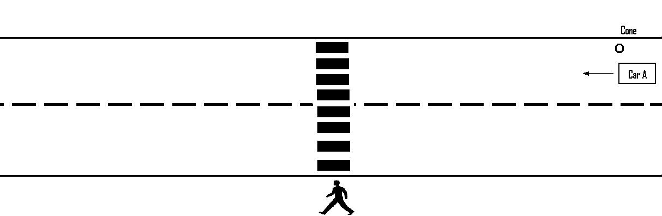

V. EVALUATION, MEASUREMENT, AND CRITIQUE
Statistical data will be compiled by Officer Ward.
VI. TARGET LOCATIONS
The targeted crosswalks will be clearly marked crosswalks that provide an unobstructed view of the crosswalks from both directions of travel.

