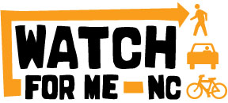**Partner Meeting**

**Thursday, Nov 20, 2014**

**10 am - Noon**

Meeting access instructions

* Go to: <https://www2.gotomeeting.com/join/419524882>
* Dial +1 (408) 650-3123
* Access Code: 419-524-882
* Meeting ID: 419-524-882

Agenda

Welcome/introductions

Part 1: Summary of Program Efforts to Date

* Enforcement
* Outreach/Education

Part 2: Partner Updates and Plans

Part 3: NCDOT plans for Watch for Me NC 2015